Azerbaijani opera singer Javid Samadov’s recital delights the audience in Montenegro
Javid Samadov - Azerbaijani opera singer, the winner of prestigious International singing competitions, had a very successful recital held in the National Theater in Podgorica, the capital of Montenegro.International piano competition winnerNargizSamadov accompanied him on the piano. The concert was organized by the Cultural and Economic center Azerbaijan-Podgorica.
Along with the world classic works, the music of the Azerbaijani composers was performed at the concert.
It was Muslim Magomayev song "The Land of Fire" which opened the program.
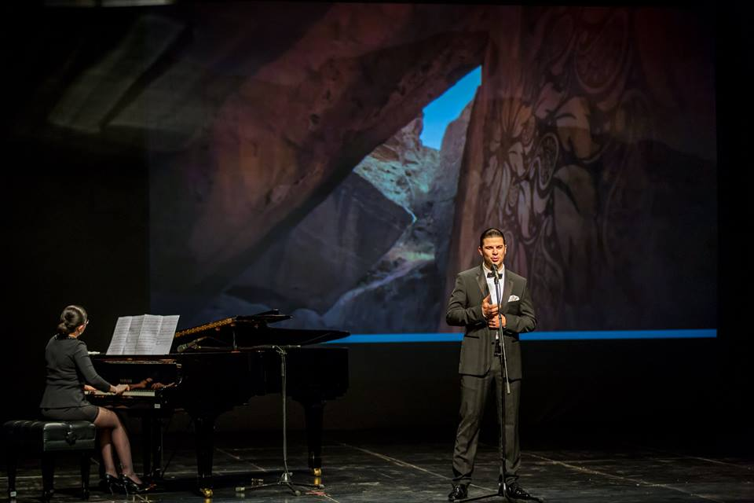
The audience warmly welcomed Mardan's aria from Kara Karaev’s and J.Gadzhiev’s opera "Vatan", the song "Ana" by Sevil Aliev, Azerbaijani folk song "Sari Gelin", as well as V.Mustafa-zadeh’s piano piece"The March".
Muslim Magomayev’s “Exultant Song”closed the evening.
The audience gave the Azerbaijani artists a warm welcome and the applause enthusiastically went on and on.
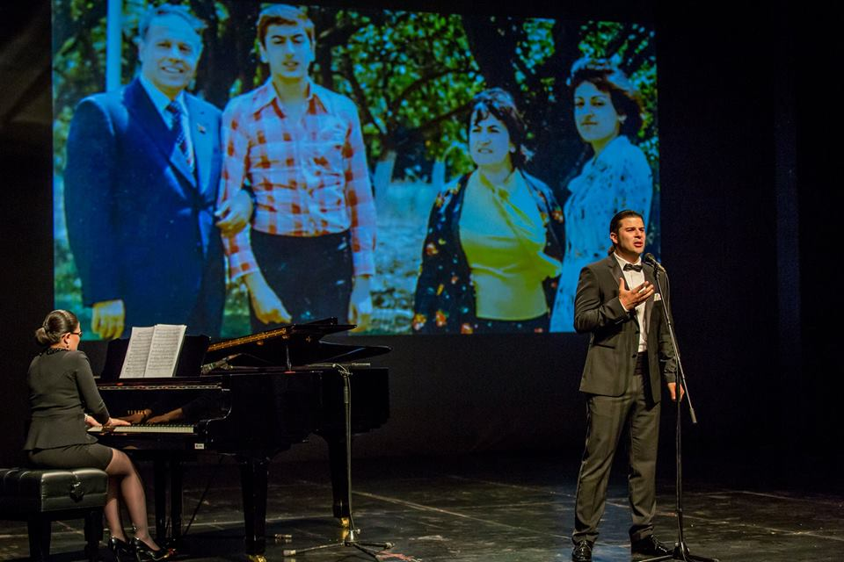
Here is an exclusive interview with Javid Samadov.
Tell us please about your recital in Podgorica.
- Firstofall, Iwouldliketoexpressmysinceregratitudetothe Cultural and Economic center Azerbaijan-Podgorica for giving us the opportunity to introduce the music of Azerbaijan to the Montenegrin public.
The concert was held to mark our National leader Heydar Aliyev’s 93th anniversary and Azerbaijan's celebration of the 10th anniversary of Montenegro’s independence.
The Chief Advisor of the Prime Minister for Political Affairs of Montenegro,Mr. Milan Rochen, addressed the audience and opened the event. He was followed by the head of the Diplomatic Mission of theAzerbaijan Republic in Montenegro, Mr. Seyran Mirzazade.
The representatives of the diplomatic mission of Azerbaijan in Montenegro took very good care of us for the whole week that we spent there.
I want to mention the great organization of the concert and rehearsals, as well as our entire stay in the country. It was an honor to personally meet with Mr. Seyran Mirzazade, the head of the Diplomatic Mission of the Republic of Azerbaijan in Montenegro and Mr. Orkhan Aliyev, a representative of the diplomatic mission of Azerbaijan.
Getting acquainted with these people, I recall our national leader Heydar Aliyev’s words: "I have always been proud and am proud today that I am Azerbaijaniani."
And I am also proud that there are such people who represent our country abroad.
At this concert you made your debut with your wife Nargiz Samedova. Is there a difference between performing with your wife and with other accompanists?
- Yes, it was a debut, but only for our duet. My wife Nargis is a professional pianist. Her stage experience began at the age of seven. Her solo performances accompanied by a symphony orchestra could be heard in the State Philharmonic Hall and in Heydar Aliyev Palace in Baku, Azerbaijan. At the invitation of Laura Bush, Nargiz also performed in the United States, in the White House where she was awarded with a personal thank you letter fromthe American president George W. Bush’s family.
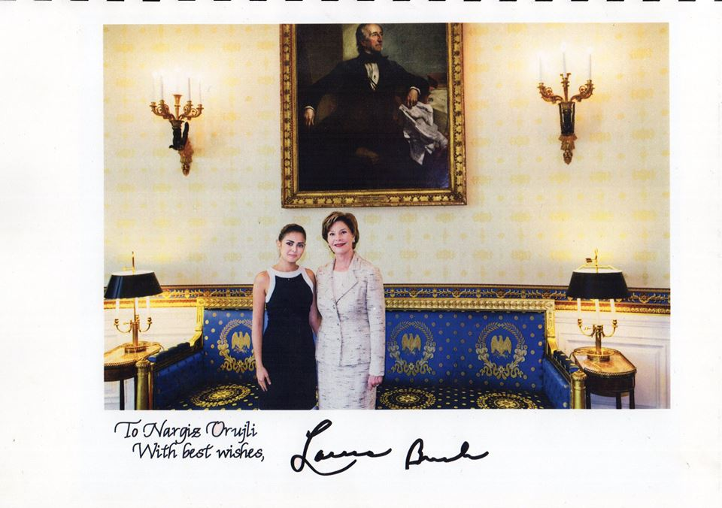
Of course, singing in this program was much more comfortable for me than ever, because for the first time I not only shared the stage with a professional pianist - accompanist, but I was also getting support from a very close person.
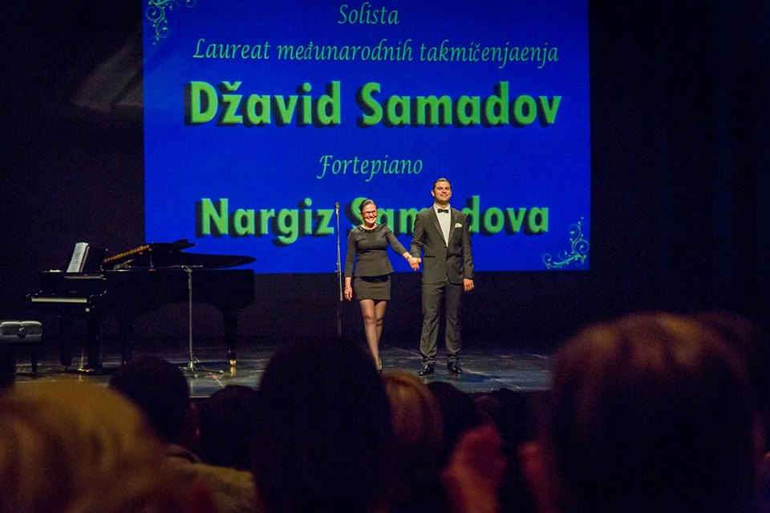
What can you say about the Montenegrin public?
- When I sing in Azerbaijan, Russia, Italy or Germany, I find it easier, as I know the audience, the people and their culture. I am well acquainted with these countries and I know how to choose the suitable repertoire. To select the repertoire for this recital was very difficult, but after the concert I realized that I was right in my prediction of the local audience’s taste. I’d heard about the warm temperament of the people of Montenegro which is very similar to Azerbaijani people, so I chose the repertoire as if I were choosing it for myown people.
The biggest problem was that I could not imagine how the public would react to a certain song or to a combination of different pieces, because the recital was made up of songs and arias in four languages ​​- Azerbaijani, Russian, Italian, Spanish; presenting four different cultures. But, fortunately, after the very first notes I sang, I could feel the public’s positive reaction. They got interested in my singing, and at that point it was even harder for me to sing on,in order not to disappoint them.
I felt a great responsibility.
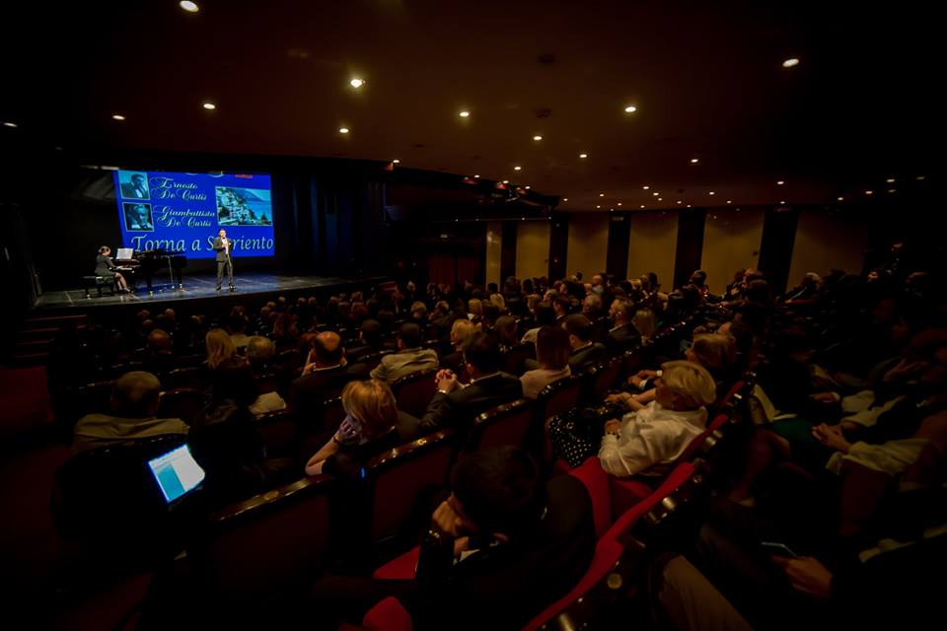
That was your first stay in Montenegro. Please share your impressions with us.
- Montenegro is a country with my favorite mountains (like in Azerbaijan), with a stunningly beautiful sea, clean air, very delicious food and very warm and friendly people. It's like heaven on the earth! I immediately felt very comfortable there.
How did the Montenegrin people react to Azerbaijani music?
- Very well. While we were staying in the resort town of Budva, we met a wonderful musician, director of the music school of Budva Nikola Vuckovic, who was present at almost all of our rehearsals with Nargis. One night, he made us a surprise - he played several pieces of Aziza Mustafa-zadeh for us. He admitted that he is a fan of this jazz pianist. After our first rehearsal he asked for the scores of Azerbaijani pieces that we performed - the aria of Mardan, "Sari Gelin", "Ana."And I am very glad that I could share the scores with him.
When will the Azerbaijani music lovers be able to hear you in Azerbaijan?
- At present, we are planning to participate in the VIII International Music Festival in Gabala, organized by the Heydar Aliyev Foundation. In recent years Gabala has become the capital of classical music in Azerbaijan. Together with Nargiz we will perform pieces of Azerbaijani, Russian, Italian and Spanish composers. Also, together with La Scala Academy student tenor Azer Rzazadeh I will take part in the final concert of the festival, with the Kiev Symphony Orchestra.
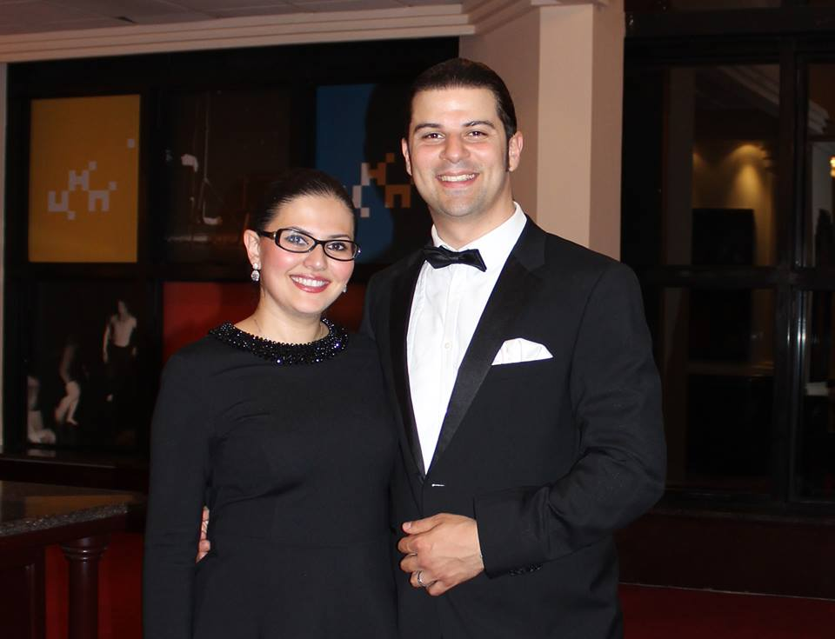
We wish both of you further success. We’d also like to wish the Azerbaijani public more frequent meetings with you in Azerbaijan.
- Thank you very much.

